History 1
Tiwanaku: Pre Incas and Aztec: The decline of a civilisation?
Main city : Tiwanaku: In Boliva . Around the size Sidmouth / Tavistock is now
Influence: Dominated parts of Peru,Chile and Argentia:. Reasonably clear its decline was in the first half of the 11 century but it was founded?? Hard as no written language

Power base : Agriculture and trade
The extensive raised field agriculture from large-scale reclamation of wetlands, dikes, aqueducts, causeways and canals. The raised fields, the most important aspect of the Tiwanaku empire's agrarian economy, was the largest expanse of raised fields in the world.
The raised beds are from 5 to 10 m wide and up to 200 m long. From 30 to 60 percent of the field surface is soil and the remainder water. The moist raised fields, and particularly the canals, capture the intense, high altitude solar radiation efficiently and conserve it to protect plants from frost on subfreezing nights. In effect, the canals are solar collectors. Experiments have produced yields up to seven times greater in restored raised fields than from unimproved common cultivation.

Textiles,pottery and knowledge of plants
Collapse: lake levels fell. Arid conditions

How knowledge changes:
Turn of C19th believed to be 10,000 BC; 1970’s thought 2000 BC 2012 paper 110 Ad form radio carbon dating and that’s the official UNESCO site figure
Drones: Evidence of more buildings and canals
Ice analysis ; eveidee for dust and droughts
Electron microscopes: Geopolymers suggesting made a cement and moulded and then carved blocks

Tiwanaku: Pre Incas and Aztec: The decline of a civilisation?
1 2
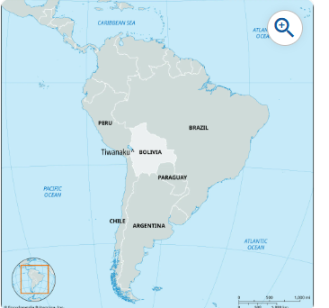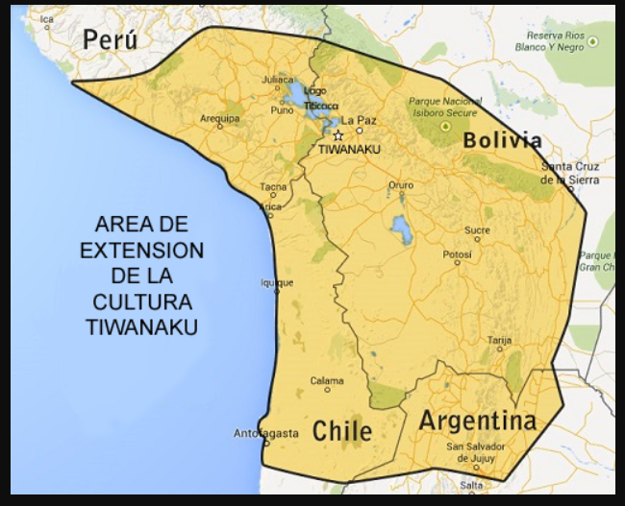
This file is licensed under the Creative Commons Attribution-Share Alike 4.0 Intern ational license
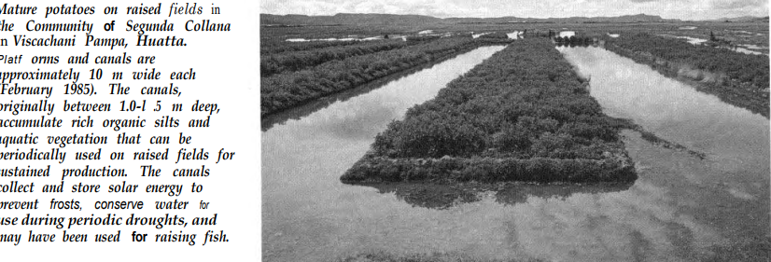
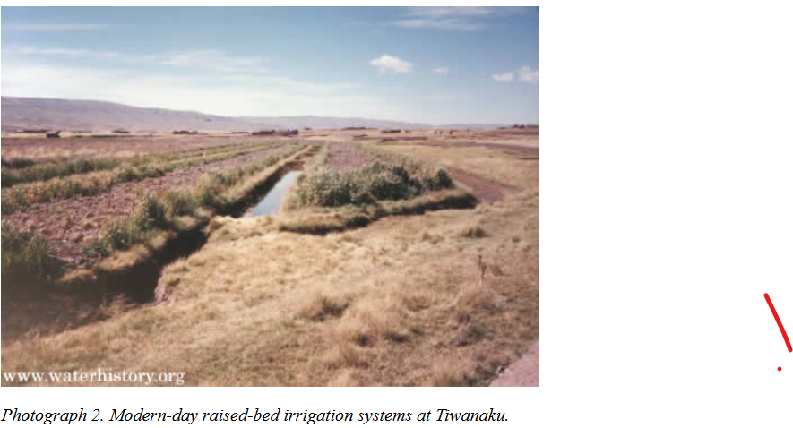
3 3
3
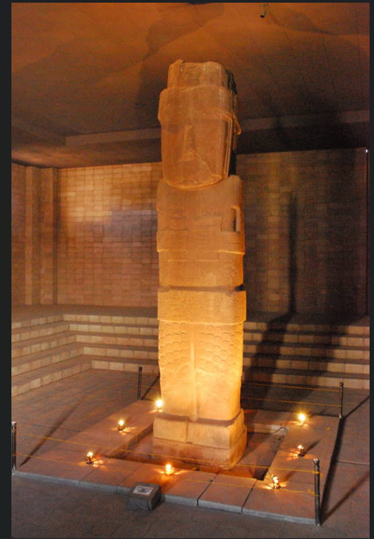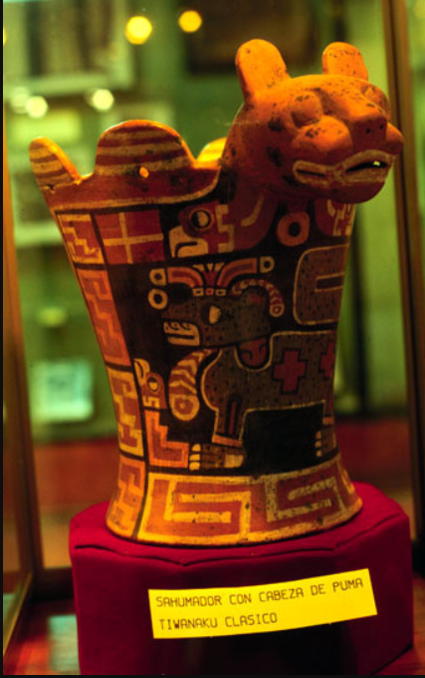
By Diego Tirira from Quito, Ecuador - BO Tihuanako (149), CC BY-SA 2.0, https://commons.wikimedia.org/w/index.php?curid=126285933

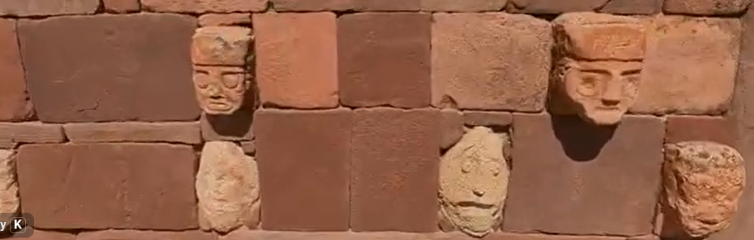
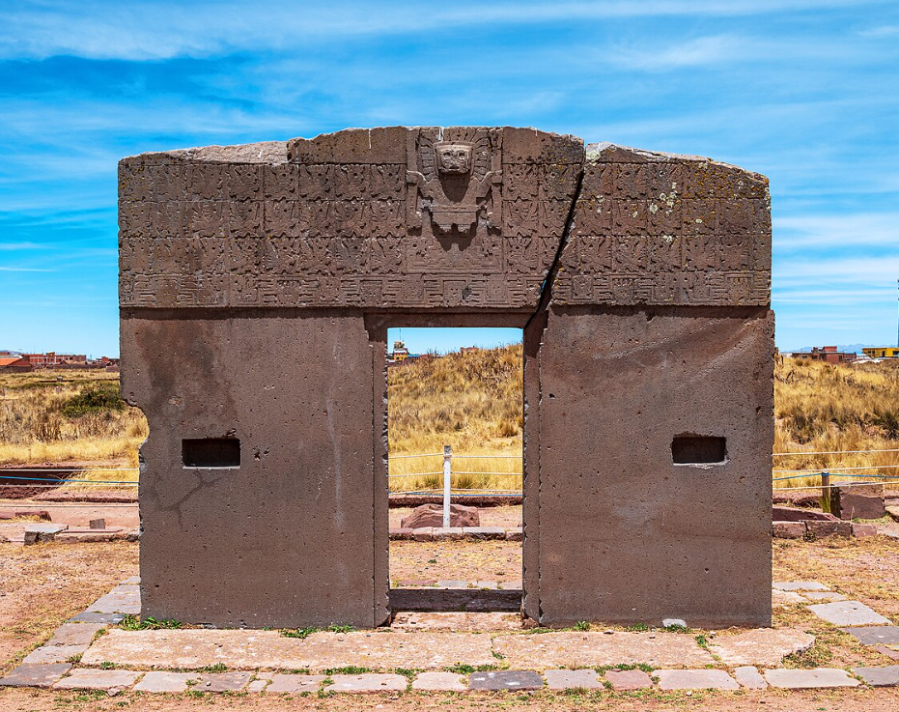 4
3
https://www.bbc.co.uk/reel/video/p0gx2hvp/tiwanaku-the-civilisation-that-mysteriously-disappeared

