India 12th Century 1199 12th Century – Delhi Qutab Minar
Period of warriors, kingdoms and fighting but also Universities, Art and wealth
After Muslims came from Afghanistan
And
Before Genghis Khan (1162 to 1227)
Indus valley – Muslims from Afghanistan
Conversion to Islam from Hindu

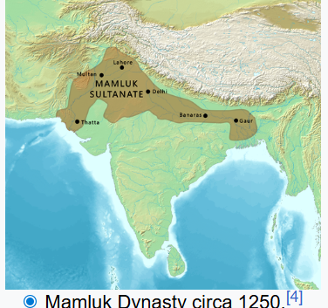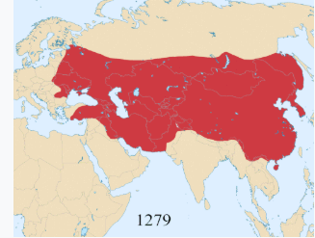
Genghis Khan had invaded lands around India
And around 30% of worlds wealth in India
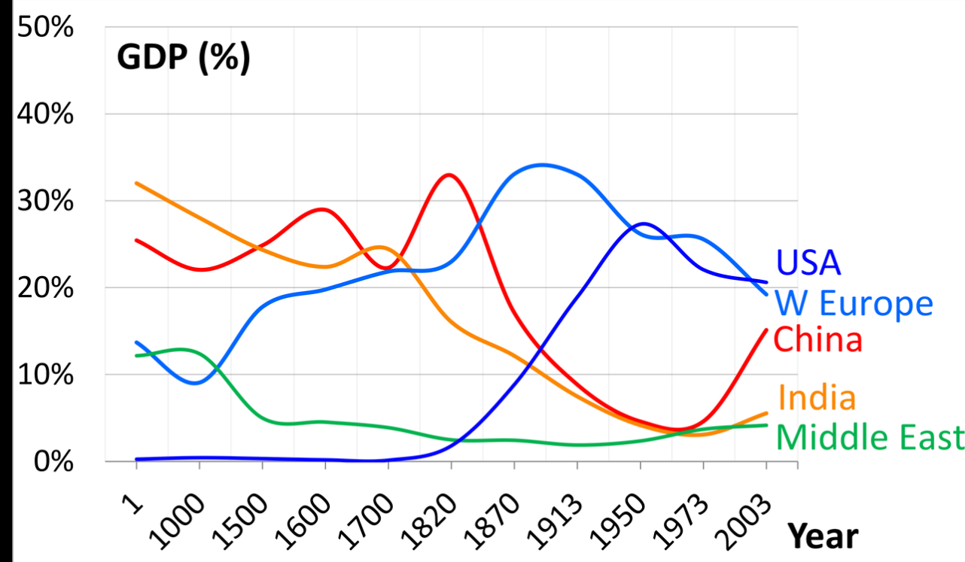

Qutab Minar- victory tower .It was mostly built between 1199 and 1220, contains 399 steps, and is one of the most-frequented heritage spots in the city. Today.

Built by a Mamluk slave -general who was put in charge by the ruling King and established the Sultanate of Delhi.[

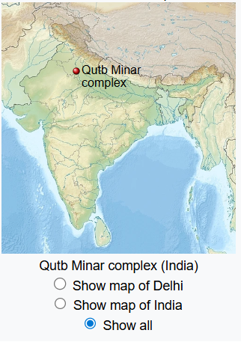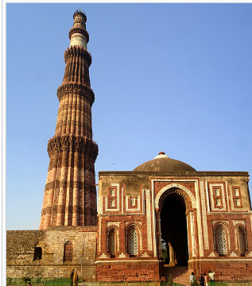
Nalanda University
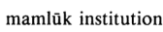
Mamluk tradition refers to the slave-warrior corps who were purchased as boys, converted to Islam, trained in military barracks, formed a strong esprit de corps, and rose as a powerful military caste and ruling class in several Muslim societies,
And art and temples And Universities .Nalalanda Buddhist monastery complex and Nalanda inscription from the 11th century mentions a gift of "revolving bookcase".^{[100]}
Especially scientist and mathematicians and astronomers.
In 1200 AD, Italian mathematician Fibonacci, a man who has been considered the ‘most talented western mathematician of the middle ages’ wrote of Indian Mathematics and their use of zero: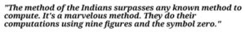
Language Sanskrit on copper plates and birch tree paper / palm tree paper.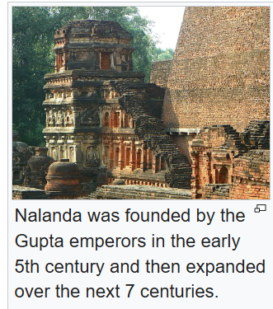Oxford 11th century 