Considered the model Prince by Muslim admirers and Christian foes alike, Saladin has been memorialized in history and legend to the present day.

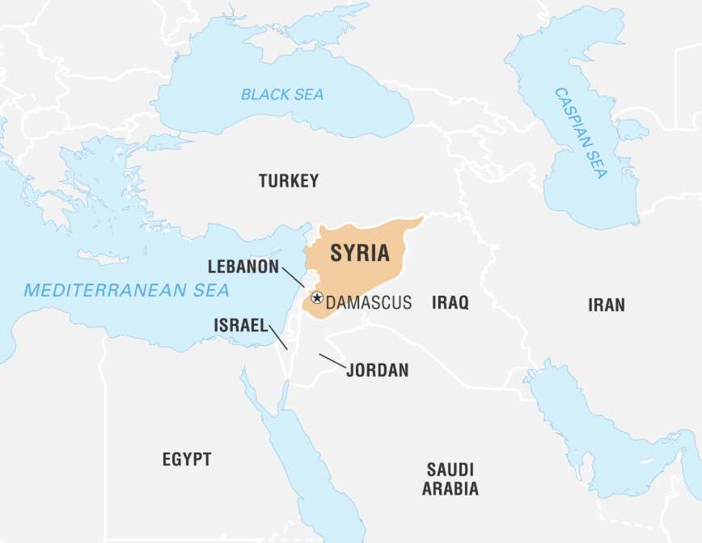
Saladin
Kurd
Military strategist
Leader
Governor
Ambitious
And lucky!!
BUT a ‘model Prince’ ??

Saladin- Born 1137 in Aleppo (north of Damascus) in Syria.
Died in 1193 in Damascus in Syria-tomb attracts pilgrims as well as tourists
Sultan of Egypt and Syria
A Sunni Muslim ruling a Shia Muslem area of Egypt
Best known: For retaking Jerusalem after 88 years in hands of Franks
Born into a high ranking military family

Portrayed as interested more in religion than military
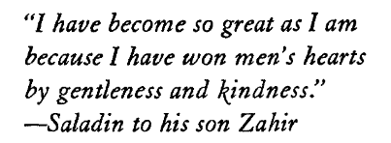

“a noble portrait of the Sultan whose chivalry and
generosity excited the admiration of the Crusaders.” *
Stanley Lane-Poole, 1898 published “ Saladin and
the Fall of the Kingdom of Jerusalem”

“Most of Saladin’s significant historical accomplishments should be attributed to his military and governmental experience, to his ruthless persecution and execution of political opponents and dissenters, to his vindictive belligerence and calculated opportunism, and to his readiness to compromise religious ideals to political expediency.”

Climate prevailing in the Near East in the second half of the twelfth century was not conducive to seeking power through the exercise of tolerance, magnanimity, chivalry, or any altruistic behavior.

- Nur-al-dn. Caliph in Syria and Saladin his Lord. Saladin sent to Egypt as his Lord supports the Egyptian Lord against attack form King of Jerusalem.

- Saladin does well. Politically astute and named as chief general in Egypt and eventually stages a coup and takes over Egypt for his Lord Nur-al-din in Syria. So Egypt and Syria all under Nur-al-din. Saladin is a Sunni Muslin and Egypt was Shia Muslim and so Saladin has much dealing with uprising to do.

- Then when Egypt safe he turns on Nur-al-din and takes Syria.That’s viewed as a major Muslim breach to take the lands of your Lord. So more practice at fighting and political pacts and breaking of truces. A group of Shia Muslims, called the Assassins, vowed to kill him and they get close at least twice- or Saladin gets lucky twice.

- But he is a good military strategist and having got Syia you might say he fancied to push out the Christians. Many skirmishes but he defeats them controlling the water supply. And whilst over half the Christians in Jerusalem bought they way out the others went into slavery.

SALADIN’S ‘SPIN DOCTORS’ Carole Hillenbrand Royal Historical society lecture 2018. Transactions of the Royal Historical Society, 2019-12, Vol.29, p.65-77
Saladin:Ehrenkreutz, Andrew S.; American Council of Learned Societies.1972
Saladin, The Latin Crusaders, and Palestine: David Eldridge's Holy Warriors and the ‘Clash of Civilisations’ Propaganda 2021

