The greatest empire after the Mongols- The Mali empire emerged in 13th century and declined in 16th . An empire almost the size of Europe with 40million people. At its heyday when Mansu Musa was Kong and made a legendary pilgrimage to Mecca

Mansu Musa and Timbuktu
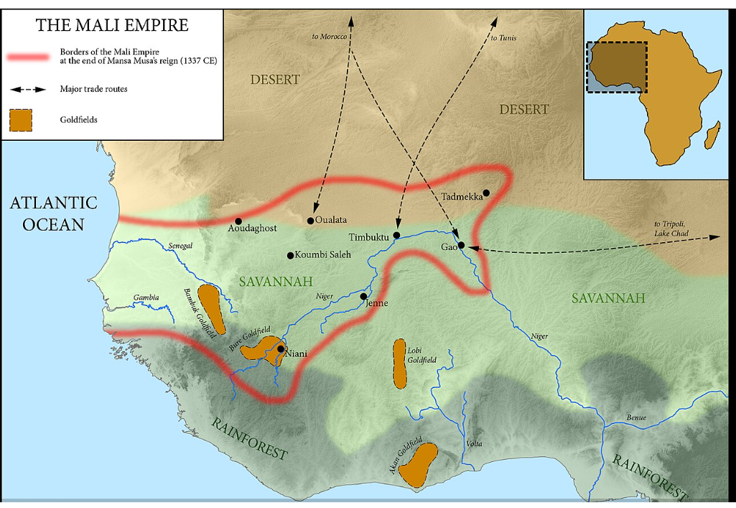
Timbuktu
Caravan routes for Gold and salt
Medieval times two thirds of worlds gold came from West Africa and nearly all of it went through Timbuktu. Salt was a precious product for West Africa
Christian and Islamic scholars settled there and 300 000 manuscripts in many private libraries and three major one (British library has 13.5 million books and 310,000 manuscripts)
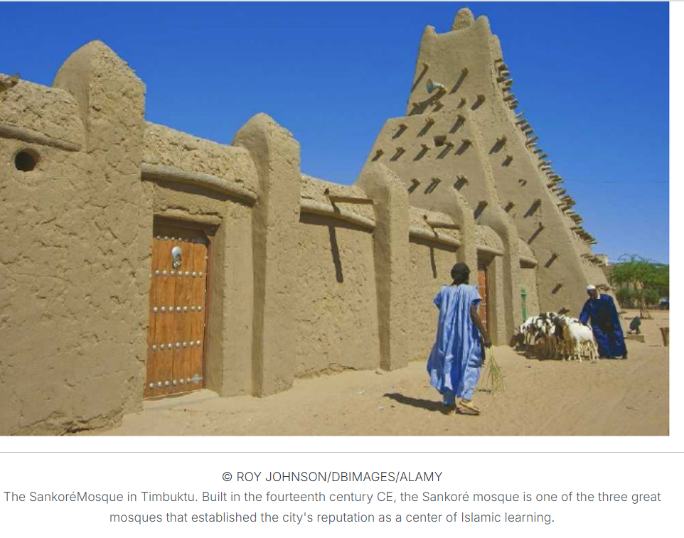
The Mali Empire occupied its greatest level of achievement during the period extending through Mansa Musa's reign (1312-1337) and that of his brother Sulayman (1341-1360)
The prosperity of Mali's rulers (mansaw) was based on its control of commercial centers and routes to the goldfields. Highly valued imports such as copper and salt were heavily taxed
The ruling elite had generally converted to Islam but the majority of population kept local religions and upto a third of the population were slaves. The trans-Sahara trade was a huge source of revenue for Mali. All religions tolerated which helped build a federation of states.
Mansa Musa founded temples and schools which provided free Islamic education for all

The tale is Mansa Musa went of pilgrimage to Mecca and that meant crossing the Sahara to Egypt. Supposedly it took the Egyptian economy a decade to recover.
And the tale?
60 000 people- mainly servants and soldiers
100 camels
Silks and brocades
Two tons of gold ( round 83 million pounds)

And The Catalan atlas- mamma mundi of 1375 included Mansu Mula
