Incas
The Inca people were a pastoral tribe in the Cusco area around the 12th century.
They massively expanded in C15 and in period 1438–1533 empire in South America
1450 building of Machu Pichu and 1533 surrendered to Spanish. Aztecs and Mayans much further North- Mexico but times overlapped.
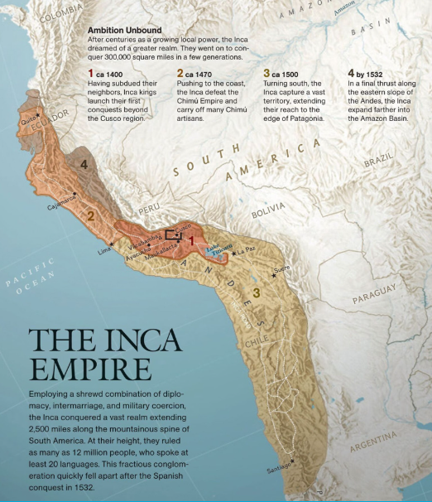
Lake Titicaca
Cusco
The Inca Empire was preceded by two large-scale empires in the Andes: the Tiwanaku (c. 300–1100 AD), based around Lake Titicaca, and the Wari or Huari (c. 600–1100 AD

Engineers, artists, freeze dried potatoes lasted 10 years,canal and terrace builders ,road builders- two main paved highways one along the coast and one inland. Runners meant messages could cover 150 miles a day. Highways had tunnels , bridges, storehouses and rest stops. – 2,500 miles !Huge stones with no gaps between;Alpacpa and Llamas and potatoes.maize veg

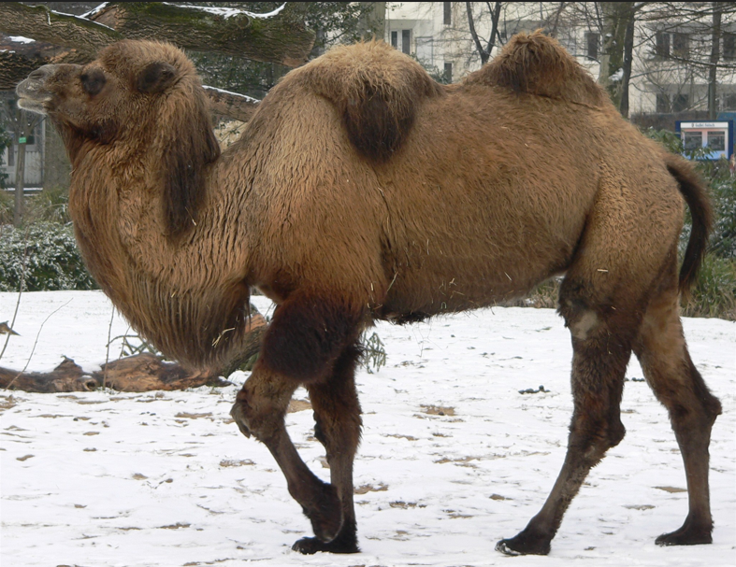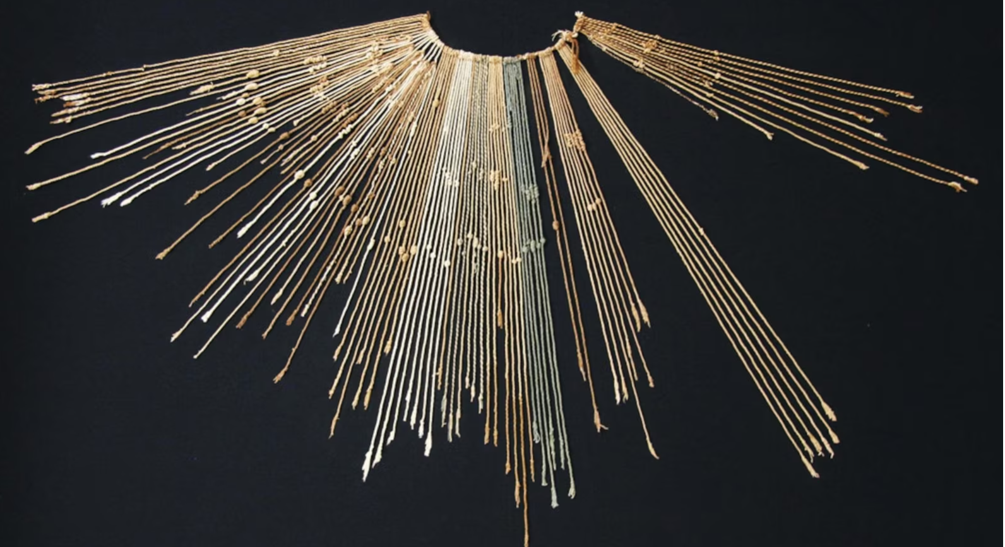

The Inca didn’t have a written language. Instead, they used knotted cords called quipu (KEE-poo) to keep records. Experts think that things like the style of the knot and the colour of the string all contained information. Researchers are using computers to try to untangle these long-
Quipu lost codes. 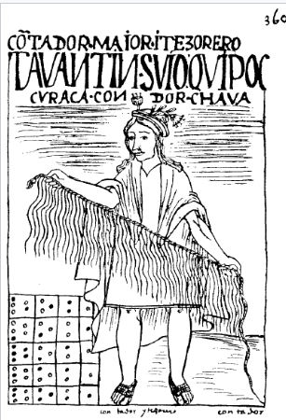
A quipu usually consists of cotton or camelid fiber cords, and contains categorized information based on dimensions like colour, order, and number

The decimal system – we went decimal in 1971. The recorded numbers on a decimal system
They had three types of knots
Standard knots called say s which marked the tens position; long knots with a number of turns and figure of eight marking end of chain. Several numbers on one thread.

- The number 107 followed by the number 51 would be represented by 1s, X, 7L, 5s, E.
