BRISTOL IN THE TWELFTH CENTURY

Context
The city of Bristol was the third largest town in medieval England within the Anglo-Saxon kingdom of Wessex. The historic town occupied the area between the River Avon and the River Frome, where a Norman Castle had been erected on the command of William the Conqueror.
As we know from my last talk William consolidated his power by building castles, crushing rebellions and introducing Norman governance.
His son, William Rufus, Wm the II, had taken the throne after Wm’s death in 1087 but he reigned only until 1100 when he was accidentally shot in the chest by an arrow while hunting in the New Forest.
It was then the turn of Henry [Wm I youngest son] to become King and during that century there were three further Kings of England :
- Stephen p[1135 to 1154,
- Henry II from 1154 to 1189 and
- Richard I [Richard the Lionheart] from 1189 to 1199.

BRISTOL
The Anglo-Saxon Chronicle of 1051 showed that Bristol had the Old English name of Brycgstow [meaning ‘an assembly place on a bridge’]. The settlement grew around a wooden bridge built across the River Avon.
This crossing point for the River Avon in Bristol, was crucial for trade and access, and was sited near the medieval Bristol Bridge, allowing ships to reach the heart of the old city.
As we all know the Avon Gorge subsequently became the famous site for the iconic Clifton Suspension Bridge [designed by Brunel in 1831 and completed in 1864] connecting Clifton and Leigh Woods – although not the old city itself.
Bristol Bridge still exists today and provides vital access into the city.

- IMAGE OF THE ORIGINAL CASTLE [circa 1088]
- PICTURE OF THE BRISTOL BRIDGE IN 1905
- THE SUSPENSION BRIDGE IN 1930 [designed by Brunel in 1831]
- IMAGE OF AVON GORGE BEFORE THE BRIDGE WAS BUILT

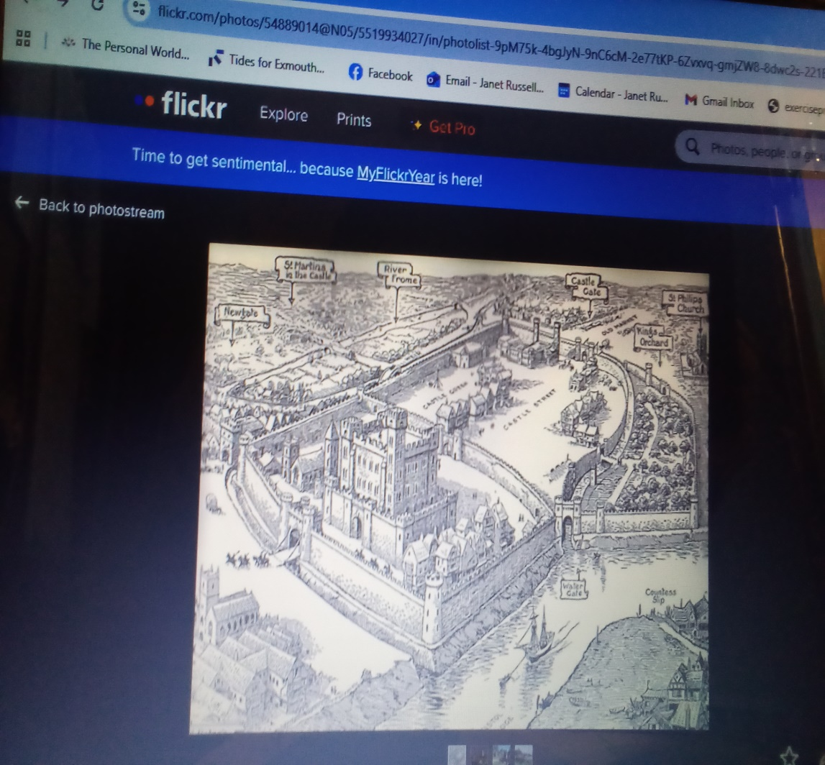
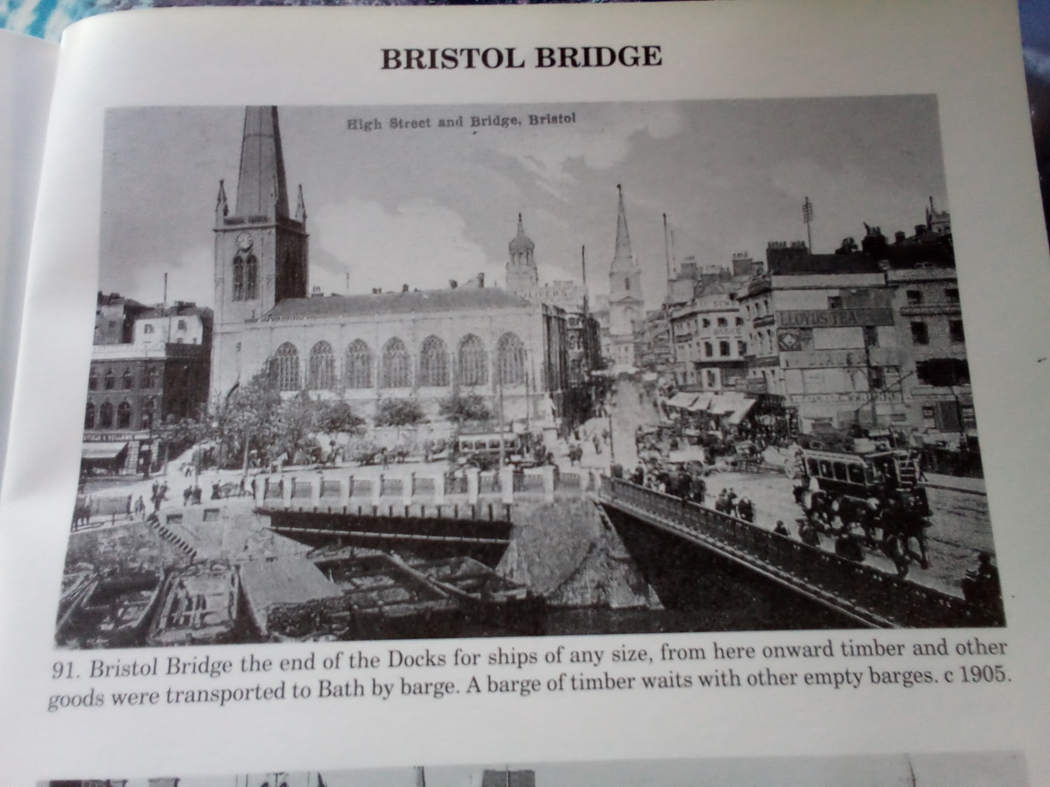
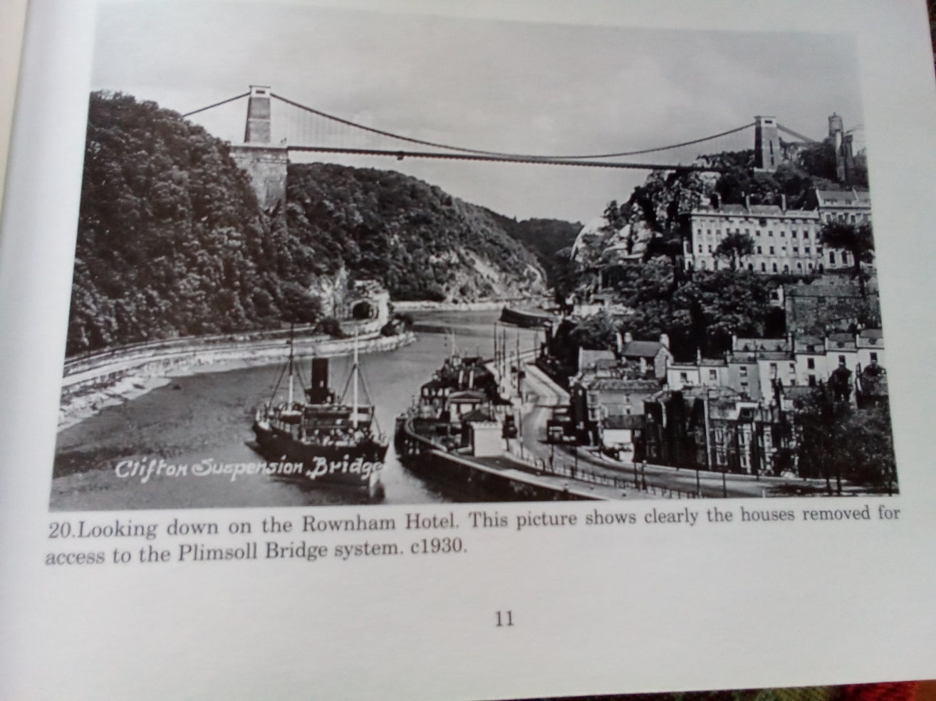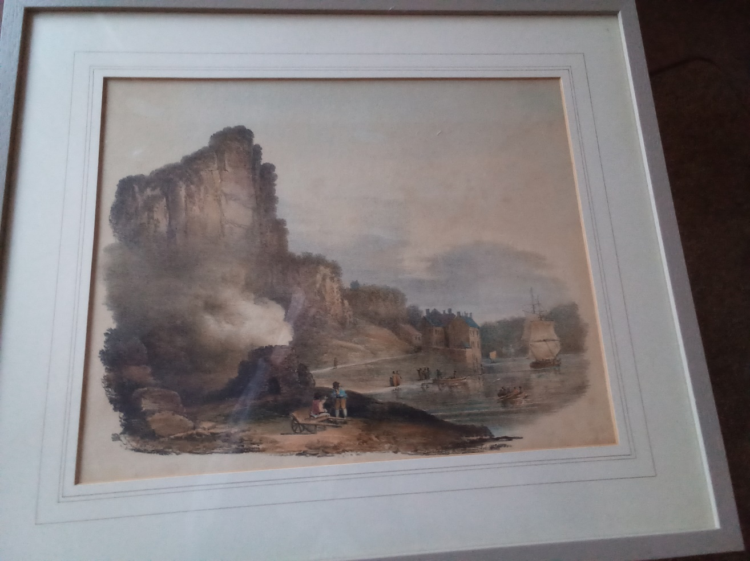
In the reign of Henry II [from 1154 to 1189] Bristol was a major trading port second only to London with a focus on trade with Ireland, Norway and France.
The trade with France was particularly strong after Henry’s marriage to Eleanor of Aquitaine in 1152 which brought parts of France under English rule and in 1155 Henry II granted the merchants of Bristol a charter which exempted them from tolls in the English-held lands in France Normandy, Anjou, Maine, Touraine, Aquitaine and Gascony]
Bristol’s secure harbour on the River Avon made it a strategic location for this maritime commerce.
As many will know, it subsequently became famous for its trade with Spain and Portugal, with Harveys of Bristol being founded in the 18th century. This company became famous for its longest wine list in the world, including of course Harveys Bristol Cream – most recently bottled in the beautiful Bristol blue glass.
As I worked for Harveys in the 1960’s and my husband was a master of wine in that company, I hope this can be a topic for me when we reach the 18th century!

